Ball Roll

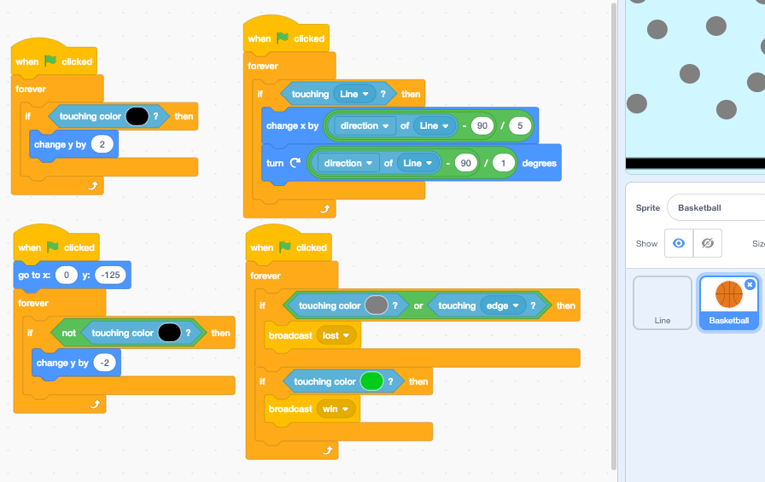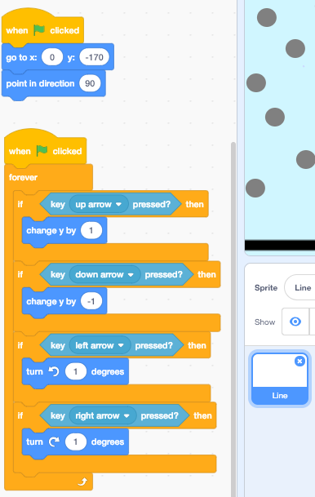

1)For the line make it simply rotate left and right

2)For the ball follow the code below.

The first piece of code makes the ball move up when you tilt the line up. It won’t go through the line.

The second piece of code makes the ball move down so it hits the line.

The third piece of code makes the ball move and rotate.

The last piece of code is for when it hits the grey and green shapes.

3)Make a player lost sprite. Hide then show it.

4)Make a player won sprite. Hide then show it.